|  |  |
| --- | --- |
| HT MICRON SEMICONDUTORES S.A.  Av. Unisinos, 1550 | 93022-750 | São Leopoldo | RS | Brasil  www.htmicron.com.br | **HT MICRON** |

# 

|  |
| --- |
| This document in a property of HT Micron and cannot be reproduced without its consent. |
| HT Micron does not assume any responsibility for use what is described. |
| This document is subject to change without notice. |

|  |  |
| --- | --- |
| SKY66420 – Characterization Measurements Report | |
| Sigfox® Monarch RF Transceiver System-in-Package | |
|  |  |
| Classification: | HW TEAM |
| Doc. Type: | MEASUREMENT REPORT |
| Revision: | Rev. 1 |
| Date: | 29/07/2020 |
| Code: | CR-SKY |

# Summary

Summary 2

1 Document info 3

2 Calibration 3

3 passive networs size evaluation 4

3.1 System Design 4

3.2 Measurement Setup 4

3.3 Measurements for 0402/0201 Components 5

3.4 Measurements for 0603 Components 5

3.5 Network performance versus size (0603 versus 0402/0201) 5

3.6 0402/0201 Components: Simulation versus Measurements 6

3.7 0603 Components: Simulation versus Measurements 7

4 skyworks sky-66420 – REFERENCE design kit 7

4.1 Reference Design Board Information 7

4.2 Measurement Setup 8

4.3 SKY-66420 – Bypass Mode 9

4.4 SKY-66420 – Transmitter Mode with Different Input Power 9

4.5 SKY-66420 – Transmitter Mode 11

4.6 Remarks 12

5 ht micron sky-66420 – characterization 12

5.1 Measurement Equipment Configuration 13

5.2 Bypass Mode Measurement 14

5.2.1 Measurement Setup 14

5.2.2 Interest Band Response 14

5.2.3 Smith Chart Response 15

5.2.4 Remarks 15

5.3 TX Mode Measurement: TX_ALT – PA_OUT PINS 16

5.3.1 Measurement Setup 16

5.3.2 Interest Band Response 16

5.3.3 Smith Chart Response 17

5.3.4 Remarks 17

5.4 TX Mode Measurement: TX_ALT – TX_IN PINS 18

5.4.1 Measurement Setup 18

5.4.2 Interest Band Response 18

5.4.3 Smith Chart Response 19

5.4.4 Remarks 19

5.5 TX Mode Measurement: TX_IN – ANT PINS 20

5.5.1 Measurement Setup 20

5.5.2 S- Parameters General Overview 20

5.5.3 S- Parameters Interest Band Response 21

5.5.4 Smith Chart Response 21

5.5.5 Remarks 22

6 CONCLUSION 23

ABBREVIATIONS 24

REVISION HISTORY 25

CONTACT 25

DOCUMENT INFORMATION 25

# Document info

To do the complete RF FEM impedance characterization, the HT Micron’s HW Team was designed a PCB realize some measurements. The measurement objectives are:

* Verify the response of two networks using SMD components with different sizes. We try two networks, one using 0402 inductors and 0201 capacitors and other using 0603 components only.
* Get the bypass mode impedance response of the RF FEM SKY66420
* Get the TX mode impedance response of the pins related to the power amplifier output, in order to design it’s matching network, in orde to minimize the transmitter losses.

# Calibration

To perform the system calibration we use an open, short, through and load calibration, respectively using u.FL connectors integrated in the characterization board, as show in the schematics bellow:

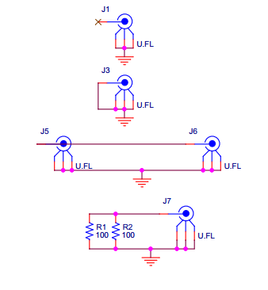

The SMA cables was calibrated using *Arthur’s calibration kit* and cable adapters. This is the PCB layout used to achieve our objectives:

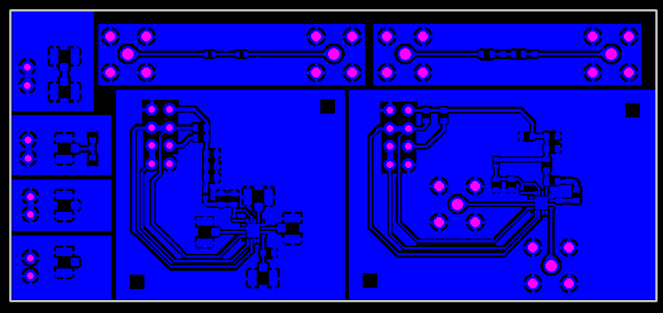

This is the manufactured and mounted PCB:

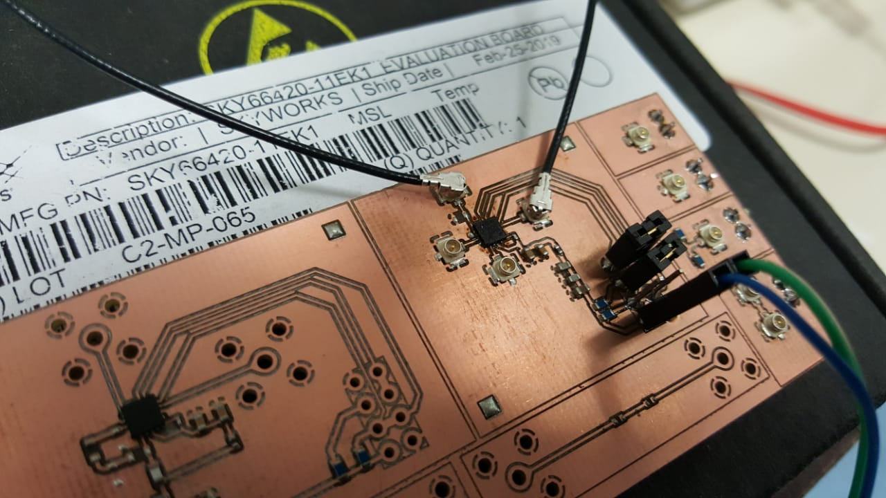

# passive networs size evaluation

## System Design

To evaluate the components size versus performance, we use a second order network:

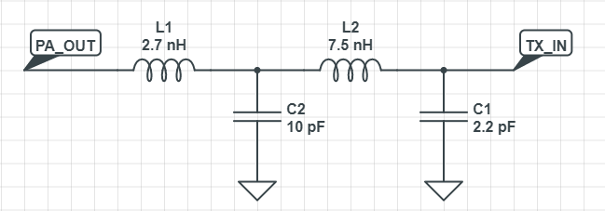

This network is suggested by the SKYWORKS RF FEM datasheet.

## Measurement Setup

For this measurement we used the Keysight Vector Network Analyzer - E5061B to get the network s-parameters.

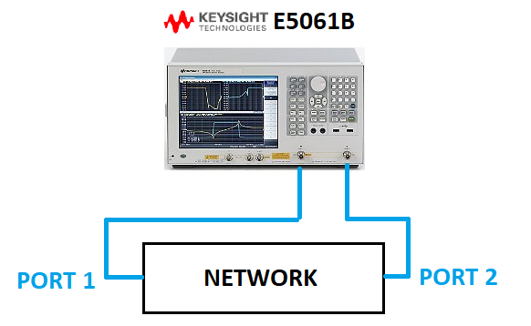

The VNA used the following configuration:

* Freq. 800MHz - 1000MHz
* 1001 pts
* Sweep Power: 10dBm
* SMA Cable Port1: NOT IDENTIFIED
* SMA Cable Port2: NOT IDENTIFIED
* Cal. Profile Label: NOT IDENTIFIED

## Measurements for 0402/0201 Components

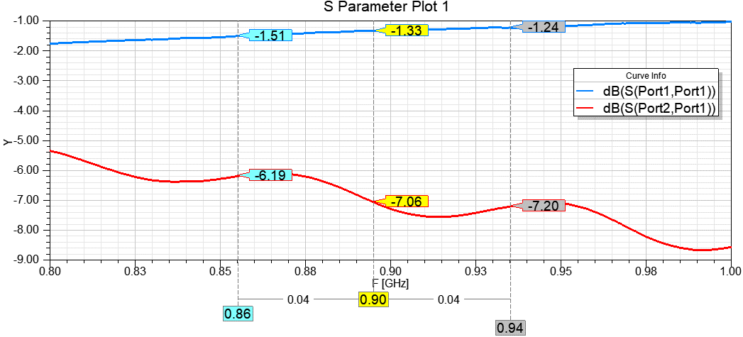

## Measurements for 0603 Components

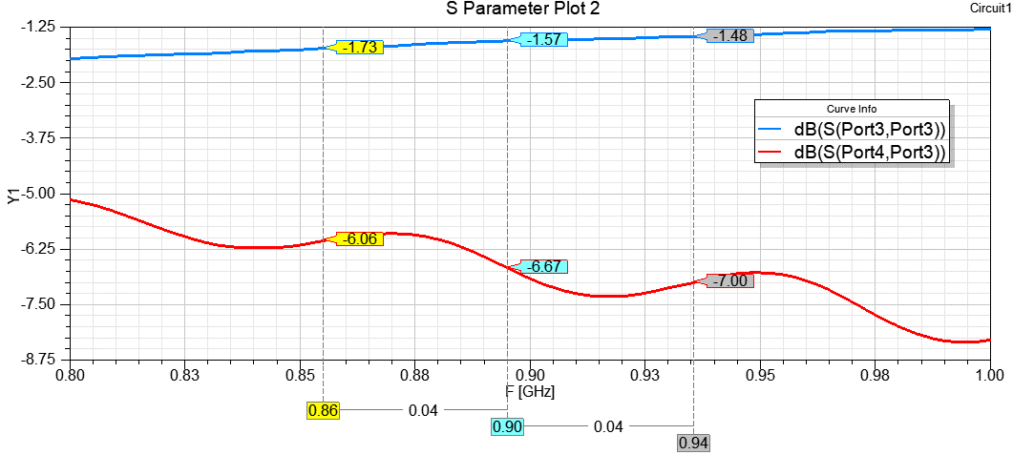

## Network performance versus size (0603 versus 0402/0201)

As we can see in the previous section the difference between the two networks in S11 and S21 parameters in no greater the 0.5dB across the band of interest. We can conclude that the 0603 components can be used to estimate and validate the performance in design prototypes without big losses.

## 0402/0201 Components: Simulation versus Measurements

S55 – S65 Simulated

S33 – S43 Measured

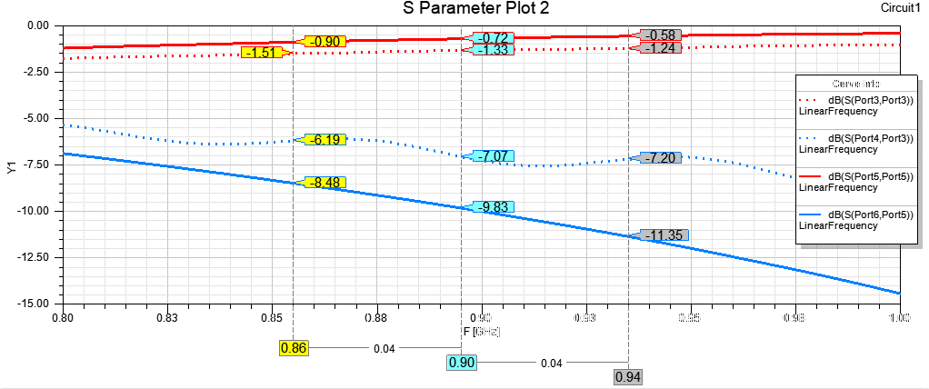

The Smith Chart response:

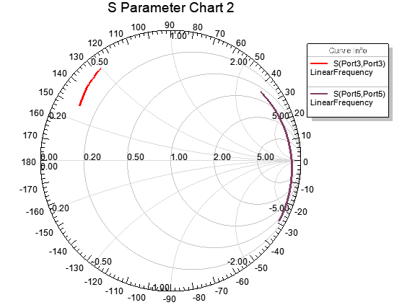

## 0603 Components: Simulation versus Measurements

S77 – S87 Simulated

S11 – S21 Measured

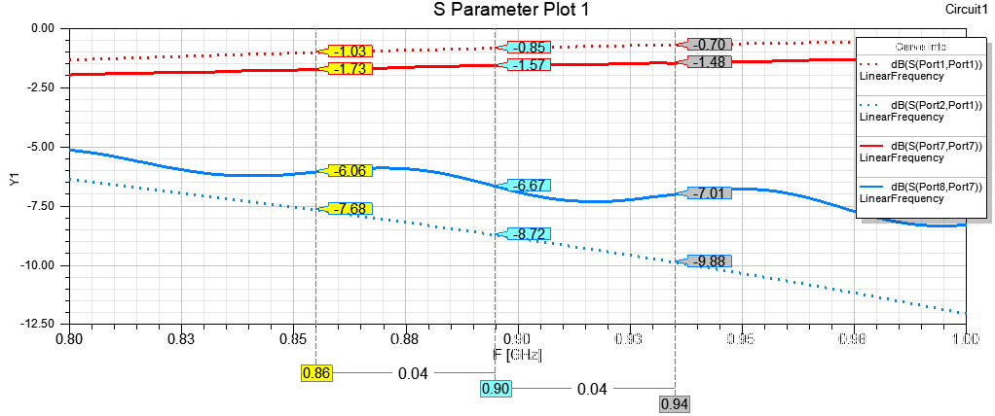

The biggest difference appears in the Smith Chart:

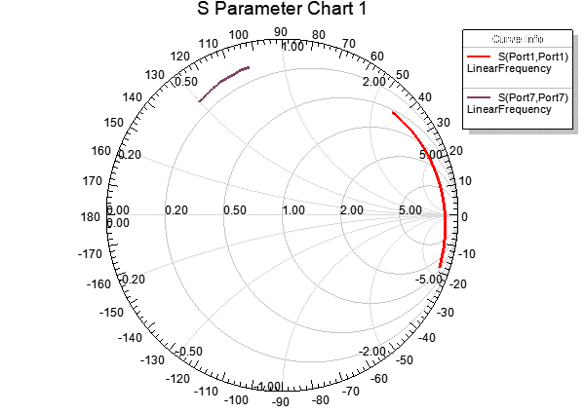

# skyworks sky-66420 – REFERENCE design kit

In this section we show the results using the reference design kit provided by the SKYWORKS in order to evaluate the SKY66420 RF FEM performance. This measurement can provide an expected “ideal” behavior for this integrated circuit.

## Reference Design Board Information

The board schematics:

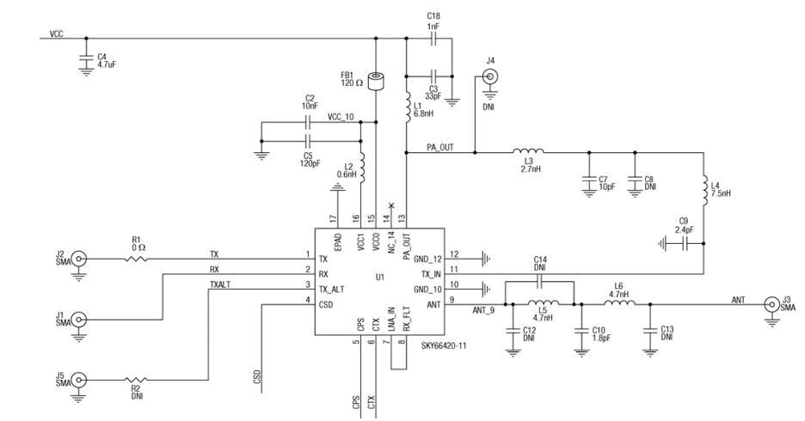

The PCB used in the measurements for this section:

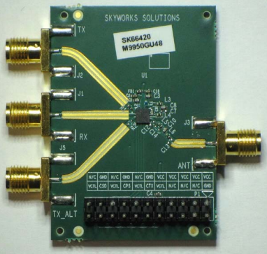

## Measurement Setup

For this measurement we used the Keysight Vector Network Analyzer - E5061B to get the network s-parameters and a standard laboratory power supply providing 3.3V.

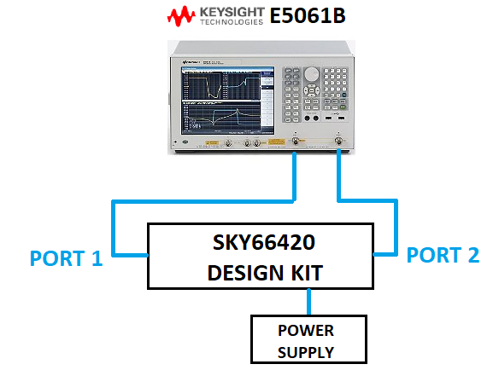

The VNA used the following configuration:

* Freq. 700MHz - 3000MHz
* 601 pts
* Sweep Power: dBm
* SMA Cable Port1: NOT IDENTIFIED
* SMA Cable Port2: NOT IDENTIFIED
* Cal. Profile Label: NOT IDENTIFIED

## SKY-66420 – Bypass Mode

MISSING FILES

## SKY-66420 – Transmitter Mode with Different Input Power

Using an 40dB attenuator we change the input power from -20dBm to 10dBm to evaluate the input impedance, the output impedance and the amplifier’s gain (S21). Note that none of this variable change considerable with the input power:

* Zin@860MHz: 33.31-j8.35 to 32.9-j9
* Zin@940MHz: 29.42-j9.28 to 28.81-j8.74
* Zout@860MHz: 49.1+j1.54 to 49.12+j1.50
* Zout@940MHz: 48.95+j1.69 to 48.94+j1.71
* Gain: around 17dB in all the cases

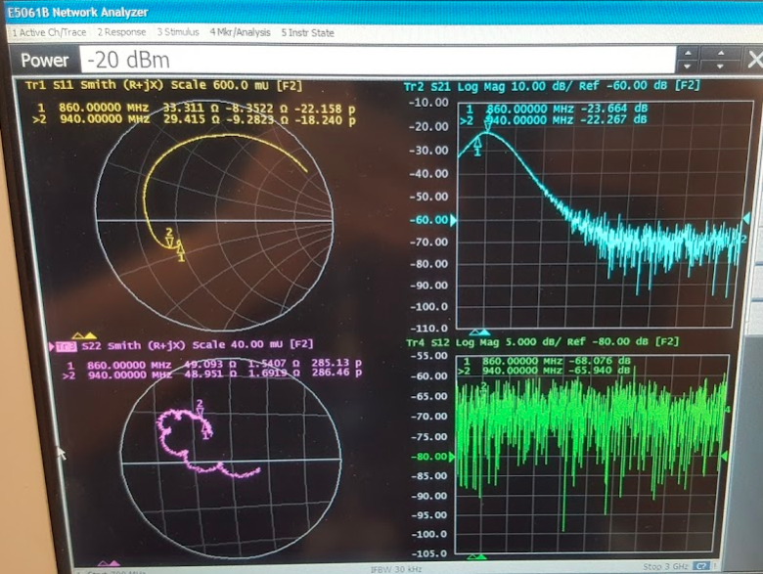

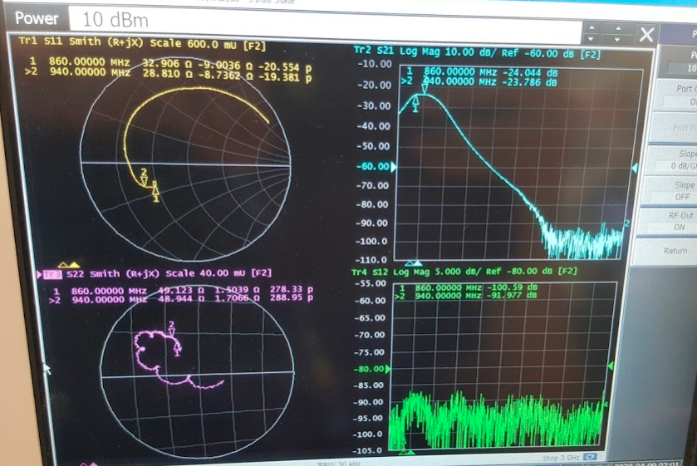

Considering an input signal with -36dBm, the amplifier achieves the same overall performance, this is a strong indicator of the pre-amplifier stage operates in a linear region.

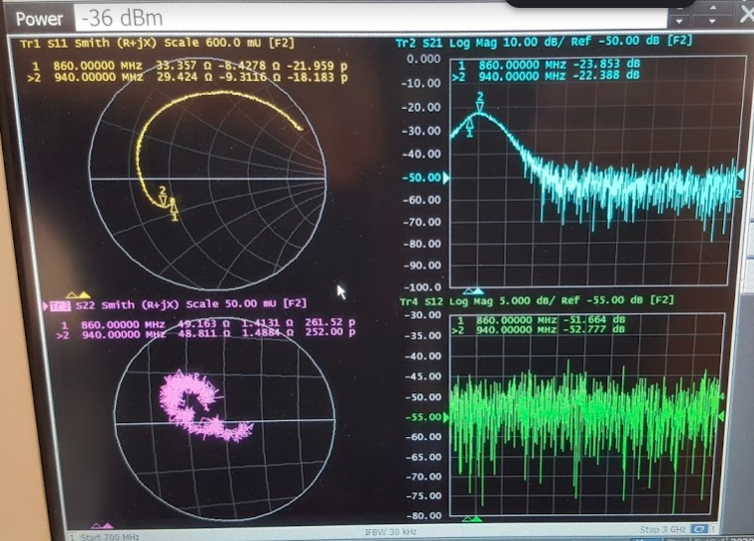

## SKY-66420 – Transmitter Mode

The measurement was done using an input signal with 6dBm, since it is the expected input power we intend to work with.

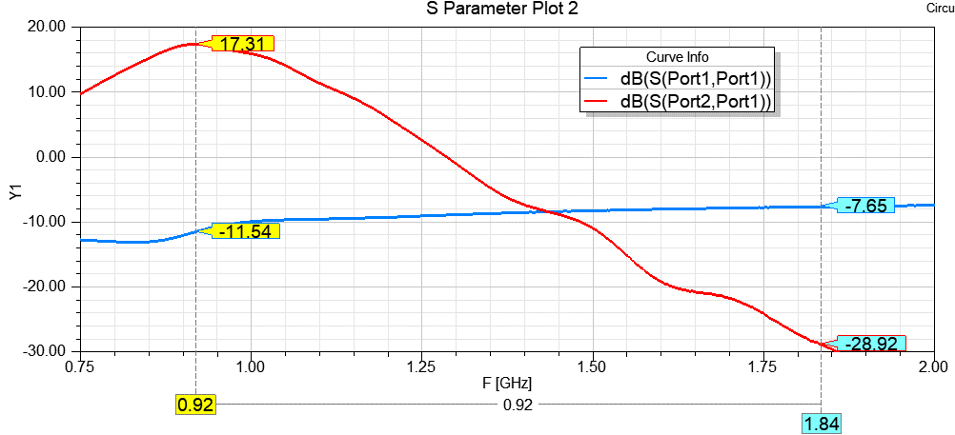

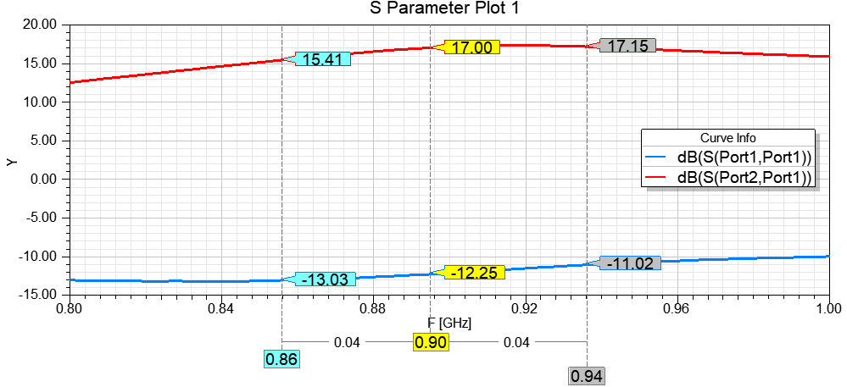

## Remarks

Based on the s-parameters analysis we can conclude:

* Worst case for input impedance is at higher frequencies
* The gain remains constant

# ht micron sky-66420 – characterization

In order to optimize and guarantee the expected TX performance characteristics, we need design an external matching network to the SKYWORKS chip. The datasheet of this RF FEM doesn’t mention about the impedance of the main interest port of this network: PA_OUT. The SKYWORKS RF FEM was characterized using the following connections:

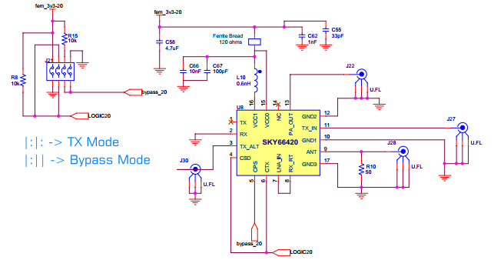

Note that the network for the transmitter path must be connected between pin PA_OUT and TX_IN. So we intend to keep all the relevant connections available to do the measurements. This is the internal block diagram for the RF FEM:

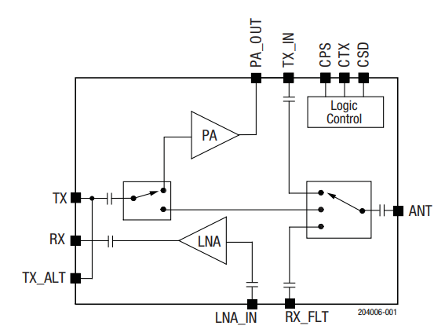

## Measurement Equipment Configuration

The VNA (Keysight E5061B) used the following configuration:

* Freq. 700MHz - 3000MHz
* 601 pts
* Sweep Power: -10dBm
* SMA Cable Port1: uFL1
* SMA Cable Port2: uFL2
* Cal. Profile Label: 2port_ufl2typeN

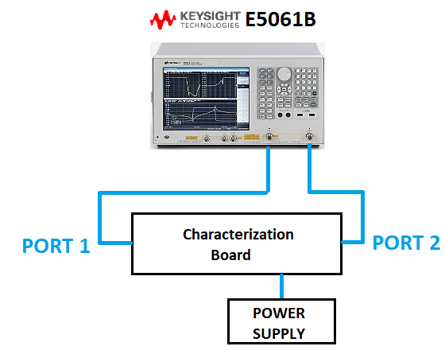

The measurement setup used:

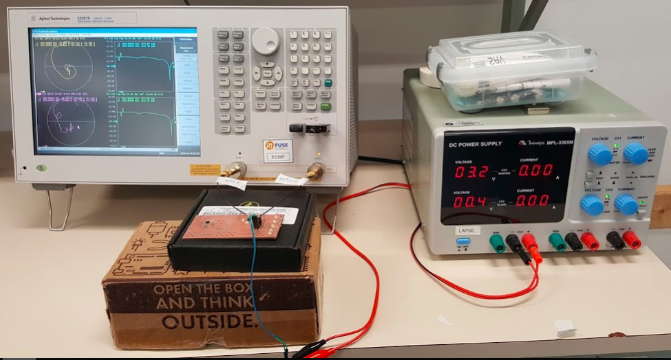

## Bypass Mode Measurement

This section brings the measurements done in the RF FEM bypass mode, relevant information regarding to the reflection and transmission losses will be addressed in this section.

### Measurement Setup

The ports of the Vector Network Analyzer (Keysight E5061B) P1 and P2 are connected as bellow:

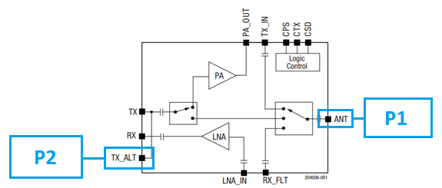

### Interest Band Response

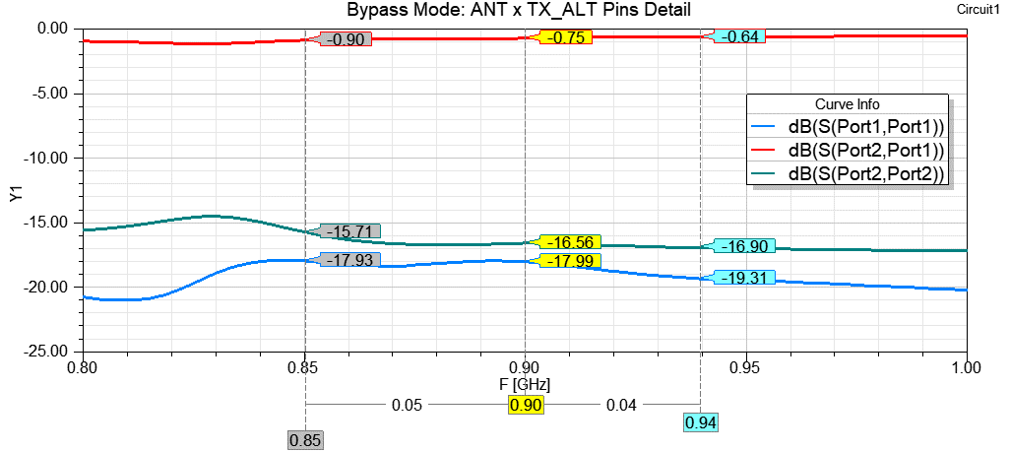

### Smith Chart Response

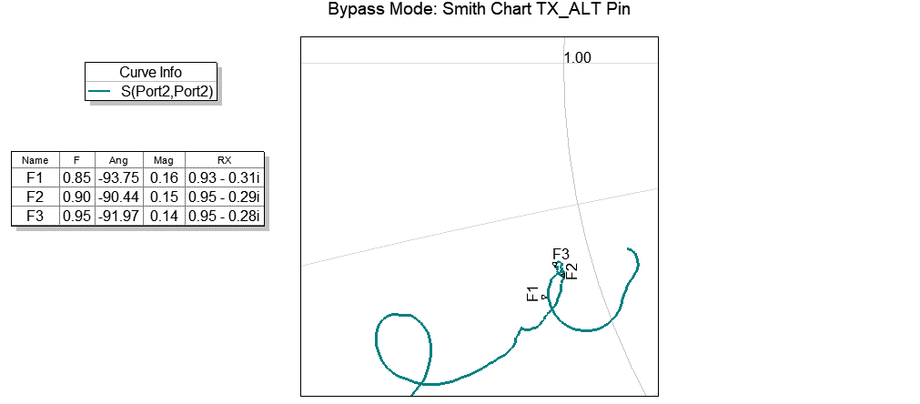

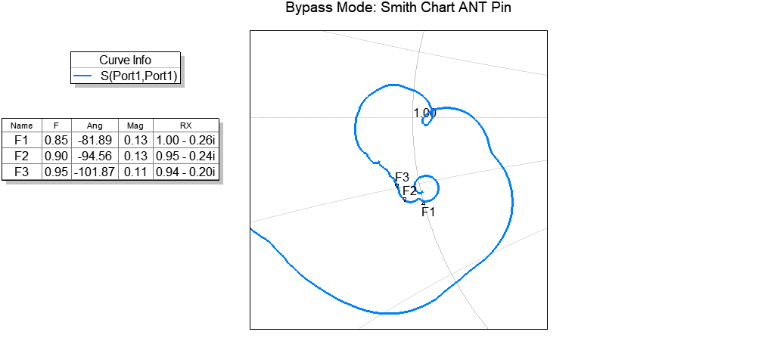

### Remarks

Based on the s-parameters analysis we can conclude:

* Worst case for transmission losses: [0.9dB@860MHz](mailto:0.9dB@860MHz)
* The output pin (ANT) is close to 50 ohms than the input pin (TX_ALT)
* Worst case for input impedance: 46.5-j16@850MHz
* Worst case for output impedance: 47-j10@940MHz

## TX Mode Measurement: TX_ALT – PA_OUT PINS

This section brings the measurements done in the RF FEM TX Mode, more specifically about the input (TX_ALT) and the output (PA_OUT) nodes of the power amplifier. The PA_OUT pin impedance is extremely important information to design the matching network properly. Relevant information regarding to the reflection and transmission losses also will be addressed in this section.

### Measurement Setup

The ports of the Vector Network Analyzer (Keysight E5061B) P1 and P2 are connected as bellow:

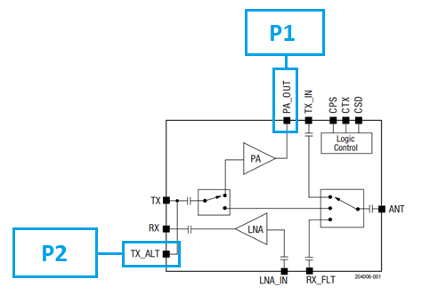

### Interest Band Response

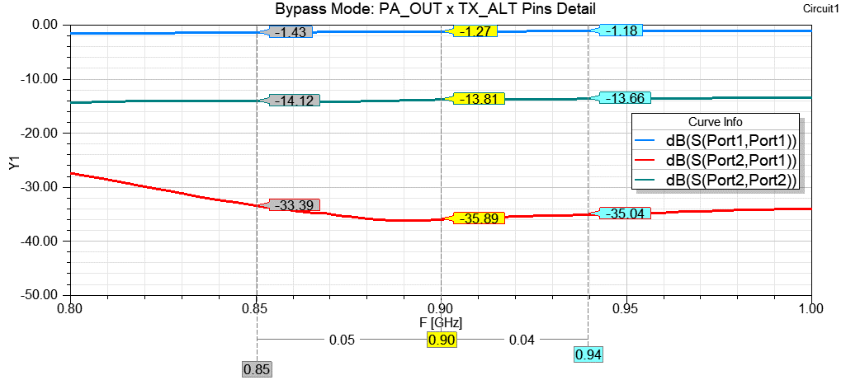

### Smith Chart Response

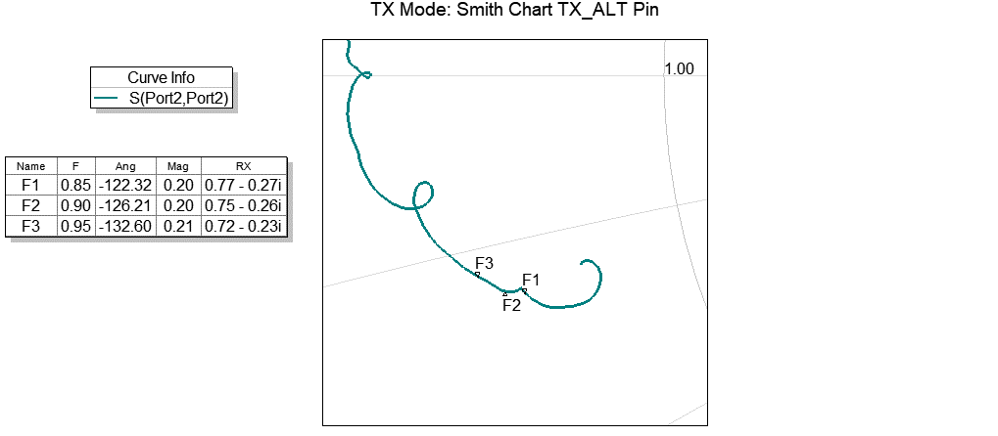

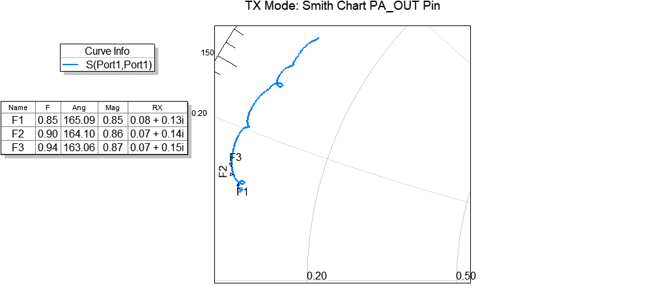

### Remarks

Based on the s-parameters analysis we can conclude:

* The output pin (PA_OUT) impedance is:
  + (4+j6.5)@850MHz ~ 7.63ohms
  + (3.5+j7)@900MHz ~ 7.83ohms
  + (3.5+j7.5)@940MHz ~ 8.28ohms
* The input pin (TX_ALT) impedance:
  + (38.5+j13.5)@850MHz ~ 40.8ohms
  + (37.5+j13)@900MHz ~ 39.7ohms
  + (36+j11.5)@940MHz ~ 37.8ohms

## TX Mode Measurement: TX_ALT – TX_IN PINS

This section brings the measurements done in the RF FEM TX Mode, more specifically about the input (TX_ALT) and the (TX_IN) pins of the power amplifier. The TX_IN pin impedance is extremely important information to design the matching network properly, setting the impedance value to be transformed from PA_OUT pin. Relevant information regarding to the reflection and transmission losses also will be addressed in this section.

### Measurement Setup

The ports of the Vector Network Analyzer (Keysight E5061B) P1 and P2 are connected as bellow:

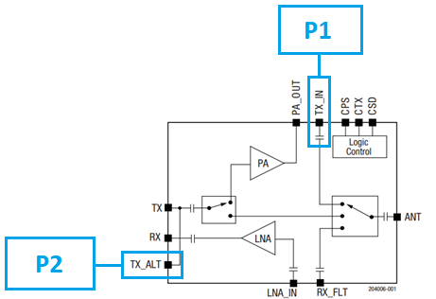

### Interest Band Response

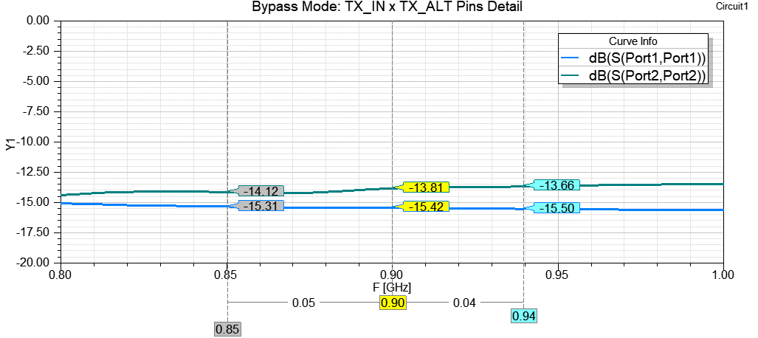

### Smith Chart Response

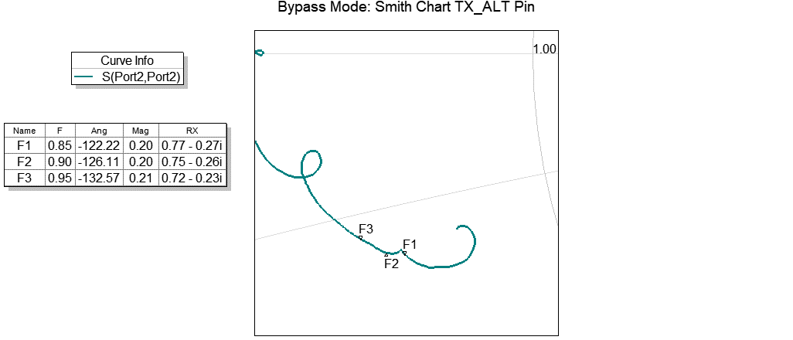

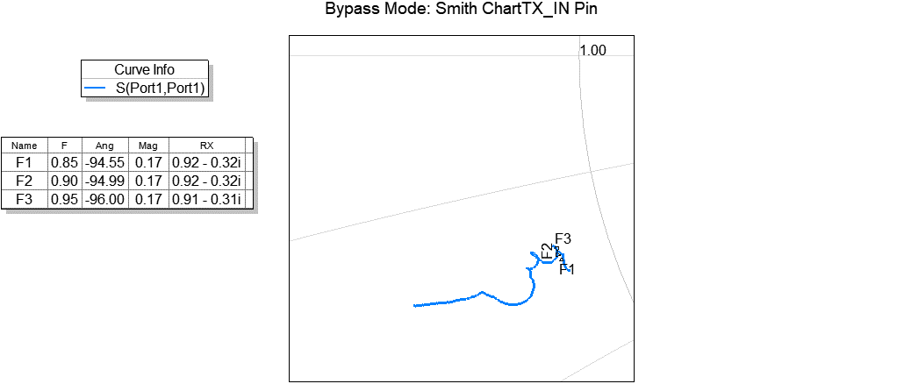

### Remarks

Based on the s-parameters analysis we can conclude:

* The S21 parameter doesn’t bring any relevant information
* The TX_IN pin impedance is:
  + (46+j16)@850MHz ~ 48.7ohms
  + (46+j16)@900MHz ~ 48.7ohms
  + (45.5+j15.5)@940MHz ~ 48ohms
* The input pin (TX_ALT) impedance doesn’t change, It’s the same as in the previous section

## TX Mode Measurement: TX_IN – ANT PINS

This section brings the measurements done in the RF FEM TX Mode, more specifically about the TX_IN and the ANT pins of the SKYWORKS system. The TX_IN pin impedance is extremely important information to design the matching network properly, setting the impedance value to be transformed from PA_OUT pin, while the ANT pin represents the output pin of the entire system. Relevant information regarding to the reflection and transmission losses between this pins will be addressed in this section.

### Measurement Setup

The ports of the Vector Network Analyzer (Keysight E5061B) P1 and P2 are connected as bellow:

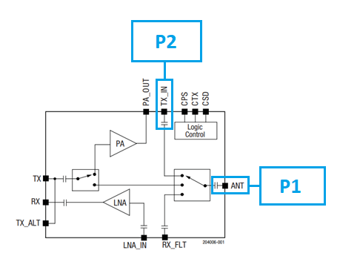

### S- Parameters General Overview

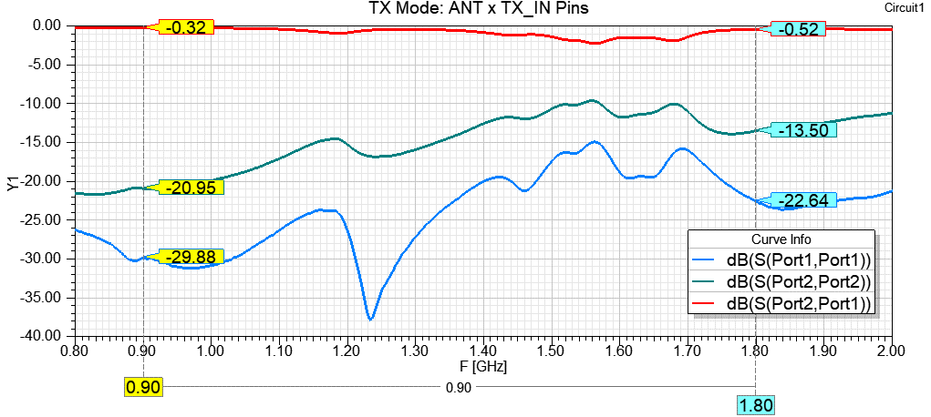

### S- Parameters Interest Band Response

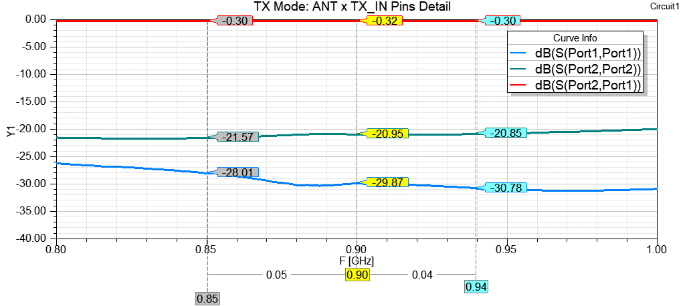

### Smith Chart Response

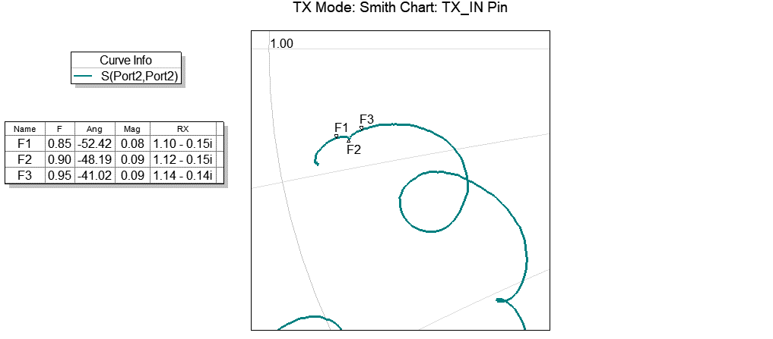

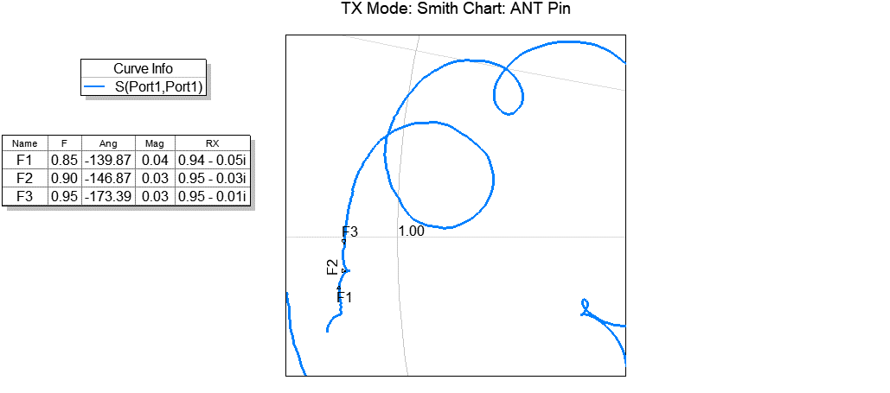

### Remarks

Based on the s-parameters analysis we can conclude:

* The ANT pin has good matching properties (in relation to 50ohms) when a 50ohms load is connected to TX_IN pin
* The TX_IN pin impedance is:
  + (55+j7.5)@850MHz ~ 55.5ohms
  + (56+j7.5)@900MHz ~ 56.5ohms
  + (57+j7)@940MHz ~ 57.4ohms
* The ANT pin impedance:
  + (47+j2.5)@850MHz ~ 47ohms
  + (47.5+j1.5)@900MHz ~ 47.5ohms
  + (47.5+j0.5)@940MHz ~ 47.5ohms

# CONCLUSION

This work brings the measurements done with the SKYWORKS SKY66420 RF FEM in Bypass and TX Modes, besides measuring the difference between two network prototypes using components with different size. At the end of the measurements we can bring to light some interesting points:

* Around the 1GHz frequency, for prototyping purpose, we can design and manufacture PCBs using 0603 SMD components and expect a performance no worse than 0.5dB for this same design using 0402 SMD inductors and 0201 SMD capacitors. This allows the R&D HT Micron’s hardware design team makes prototypes faster without losing the performance insights. The rework using bigger components also would accelerate the hardware design processes.
* With the objective to get information to design the power amplifier matching network we can relate the PA_OUT pin impedance to the following values in relation to the frequency range:
  + (4+j6.5)@850MHz ~ 7.63ohms
  + (3.5+j7)@900MHz ~ 7.83ohms
  + (3.5+j7.5)@940MHz ~ 8.28ohms
* The matching network can have a termination in 50 ohms, regarding to the TX_IN pin, this allows a good matching for the ANT pin also
* Between the pins TX_IN and ANT we have a switch with transmission loss of 0.32dB in the worst case
* The input impedance of the TX path (TX_ALT pin) is close to 50 ohms in the Bypass Mode:
  + Bypass Mode:
    - [46.5-j15.5@860MHz](mailto:46.5-j15.5@860MHz) ~ 49 ohms
    - [47.5-j14.5@900MHz](mailto:47.5-j14.5@900MHz) ~ 49.6 ohms
    - [47.5-j14@950MHz](mailto:47.5-j14@950MHz) ~ 49.5 ohms
  + TX Mode:
    - (38.5+j13.5)@850MHz ~ 40.8ohms
    - (37.5+j13)@900MHz ~ 39.7ohms
    - (36+j11.5)@940MHz ~ 37.8ohms
* The output impedance of the TX path (ANT pin) is slightly close to 50 ohms in the Bypass Mode:
  + Bypass Mode
    - (50+j13)@850MHz ~ 51.7 ohms
    - (47.5+j12)@900MHz ~ 49 ohms
    - (47-j10)@940MHz ~ 48.1 ohms
  + TX Mode
    - (47+j2.5)@850MHz ~ 47ohms
    - (47.5+j1.5)@900MHz ~ 47.5ohms
    - (47.5+j0.5)@940MHz ~ 47.5ohms
* In the Bypass Mode the transmission loss worst case is 0.9dB occurs in 850MHz

# ABBREVIATIONS

Table 1: Abbreviations

|  |  |
| --- | --- |
| Acronym | Description |
| ADC | Analog to Digital Converter |
| AES | Advanced Encryption Standard |
| API | Application Program Interface |
| CLK | Clock |
| EEPROM | Electrically-Erasable Programmable Read Only Memory |
| FIFO | First in First Out |
| GPIO | General Purpose Input Output |
| ID | Identification |
| IF | Intermediate frequency |
| IO | Input Output |
| MSL | Moisture sensitivity level |
| PCB | Printed-Circuit Board |
| PHY | Physical |
| SPI-bus | Serial Peripheral Interface -bus |
| PWM | Pulse Width Modulation |
| RAM | Random Access Memory |
| RC | Remote Control |
| RF | Radio Frequency |
| RoHS | Restriction of Hazardous Substances |
| RSSI | Receive Signal Strength Indication |
| RX | Receiver |
| SCL | Serial Clock |
| SDA | Serial Data |
| TX | Transmitter |

# REVISION HISTORY

|  |  |  |  |
| --- | --- | --- | --- |
| Date | Version | Changes | Authors |
| 17/04/2020 | 00 | - Initial draft | FK |
| 29/07/2020 | 01 | - Added comparative between simulated and measured networks | FK |
|  |  |  |  |
|  |  |  |  |

# CONTACT

HT MICRON SEMICONDUTORES S.A.

Av. Unisinos, 1550 | 93022-750 | São Leopoldo | RS | Brasil

github.com/htmicron/ht32sx

support_iot@htmicron.com.br

www.htmicron.com.br

# DOCUMENT INFORMATION

Document Title: SKY66420 – Characterization Measurements Report

Document Subtitle: Sigfox® Monarch RF Transceiver System-in-Package

Classification: HW TEAM

Doc. Type: MEASUREMENT REPORT

Revision: Rev. 1

Date: 29/07/2020

Code: CR-SKY